LT3 Indigenous activity

This activity specifically targets the construct/deconstruct portion of the 8Ways pedagogy. It can also be used through lank links, by identifying how and where native bees live and how they may have been used in traditional horticulture.

Students will be presented with resources that show a completed beehive, designs and instructions for building the beehive. They will also be able to deconstruct an example beehive, if they choose to, in order to investigate how it was constructed. The activity will be designed to allow for students to individually explore the beehive construction as well as be shown how to construct before attempting themselves, it if they choose. It will also be designed to allow for group and individual discussions, to allow for the development of ideas and/or methods to complete the activity.

The project allows for investigation using natural products and may also allow for exploration and discussion of sustainable practices. This will consider our connection and responsibility to the environment, which can be related to Land Links from 8Ways Online.

Learning Intention – Students will investigate native beehive materials and construction, and choose or design a beehive, that they will construct.

Introduction – Show students how native bees produce “sugar bag” (the term for native bees’ honey) and their effect on the environment. [Video](https://www.youtube.com/watch?v=xH7pk4XjZDs) watch up to 2:00. Remainder can be watched during body of the lesson if desirable.

Show a constructed beehive and diagrams or blueprints on their construction.

Body – Students will be allowed to investigate in groups or individually: the materials used and required, the various designs, natural beehives and how to construct a beehive.

Conclusion – Students review and discuss what materials they intend to use to construct their beehive and the plan they have chosen or designed themselves.

8 WAYS. (n.d.) 8 Aboriginal Ways of Learning. Aboriginal Pedagogy. <https://www.8ways.online/>

<https://www.aussiebee.com.au/hive-designs-stingless-bees.html>

<https://www.nativebeehives.com/category/box-building/>

<https://www.treehugger.com/how-build-hotel-wild-bees-4863814>

<https://zabel.com.au/australian-stingless-native-bees/ressources/>

Alt Teaching Model/Activity

This activity is an online learning platform, that teaches from basics of coding and ICT skills. Specifically, for this activity, students will be focused on learning how to write python script. This teaching technique is no limited to Grok Learning; other popular platforms are Code Academy and Code.org.

This activity capitalises on the interest of students within the online and digital world, and as such, the content is developed in a purely online interface. Students are able to conduct self-paced learning, as they are taught through the platform and are tested regularly to confirm learning. The testing is conducted in two formats. The first, is through formative assessment, where learners are given problems designed to develop problem solving based on short lessons already taught. These assessments are not pass or fail but are used to confirm they are understood the content. The second assessment does not allow for any assistance and are part of their summative grade. Further, their attempts at the summative assessments are limited, forcing more deliberate critical thinking.

This activity is based on Technological, pedagogical and Content Knowledge (TPACK) framework, specifically technological. Students will be able to relate the skills learnt through other subjects and general capabilities, in particular ICT Capability. The use of the online interface is familiar to 21st Century Learners therefore capitalising on their interests and strengths.

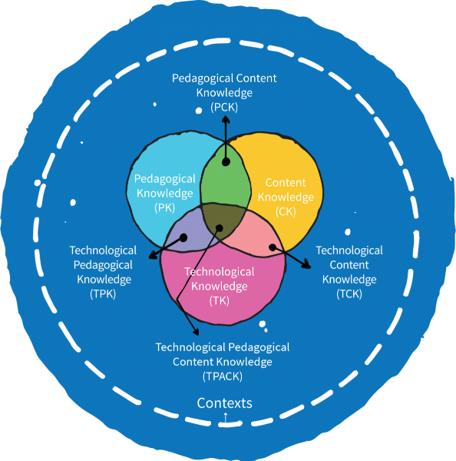

<https://groklearning.com/>

<https://www.codecademy.com/learn/learn-python>

<https://code.org/>